# **Exercise 7: Integrated Analysis - K-means Clustering using Tableau & R**

**Q1**

Number of Rows : 891

Number of Columns : 12

**Q2)**

Average age is 29.69

**Q3)**

**Q4)**

**Q5)**

I have 4 clusters for the analysis

**Q6)**

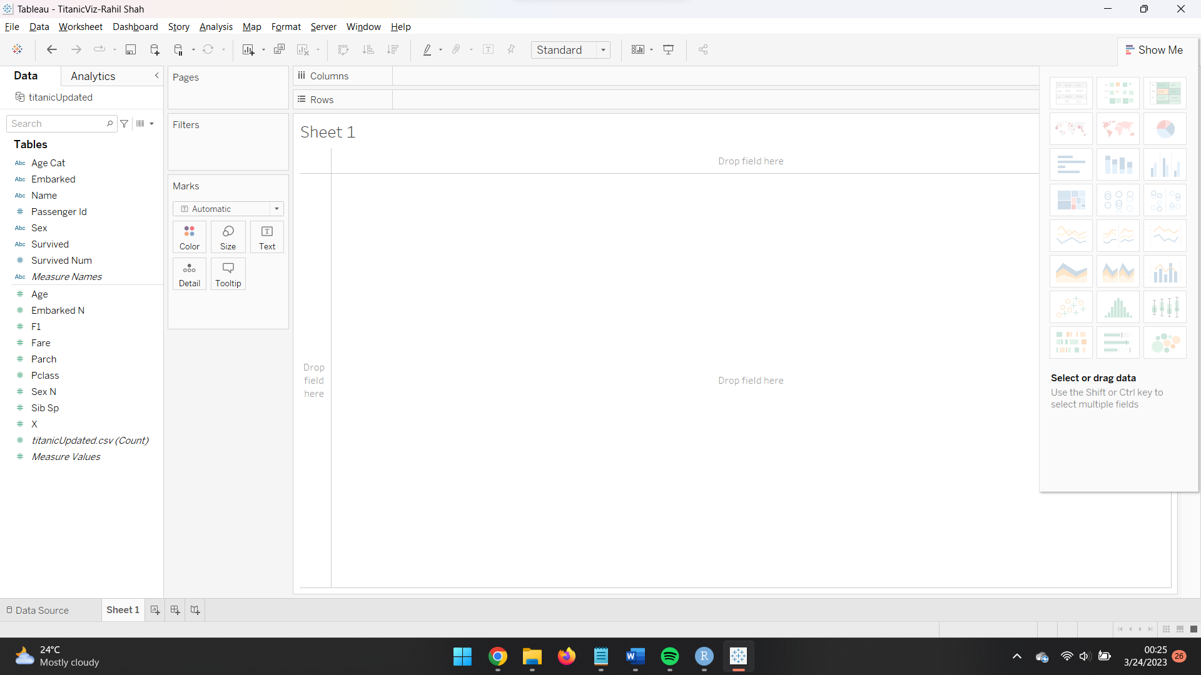

**Q7)**

**Q8)**

**Q9)**

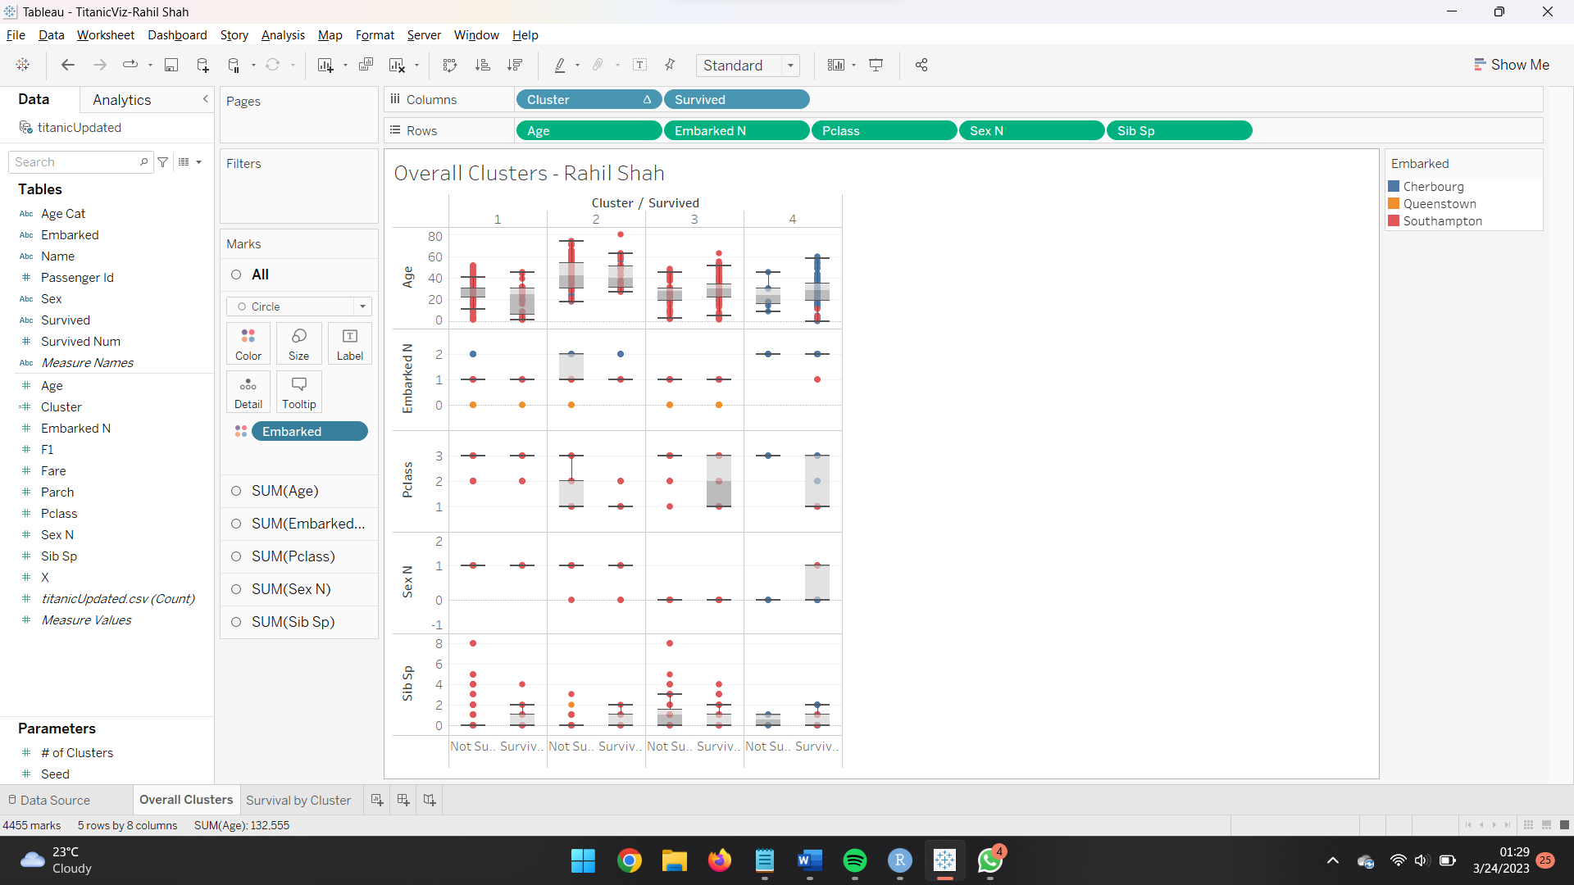

**Q10)**

Insights from Cluster 1

1. The first cluster shows that individuals who did not survived had an age range between 11 and 41, with a lower whisker at 11 and an upper whisker at 41. This suggests that most people who did not survived fell within this age range. On the other hand, individuals who survived had ages ranging from 1 to 45.
2. Those who did not survived departed from three different ports: Cherbourg, Southampton, and Queenstown. In contrast, those who survived only departed from Southampton and Queenstown.
3. In cluster 1, both the survivors and non-survivors had only two values for their passenger class, which were 2 and 3.
4. Cluster 1 solely consist of Male passengers.
5. Individuals who did not survived had a greater number of siblings, whereas those who survived had fewer siblings.

**Q11)**

Insights from Cluster 4

1. In Cluster 4, the age range of those who did not survived ranges from 9 to 45, whereas that of those who did survived ranges from 0 to 58.
2. Those who did not survived were the only ones from Cherbourg, whereas those who survived were from Southampton and Cherbourg.
3. The Passenger Class for not survived consist of people from Pclass 3 and those who survived consist of Pclass 1,2 and 3
4. Those who did survive had both male and female sex, whereas those who didn't had only female sex.
5. Those who did not survived had fewer siblings, whereas those who did survived had more.

**Q 12)**

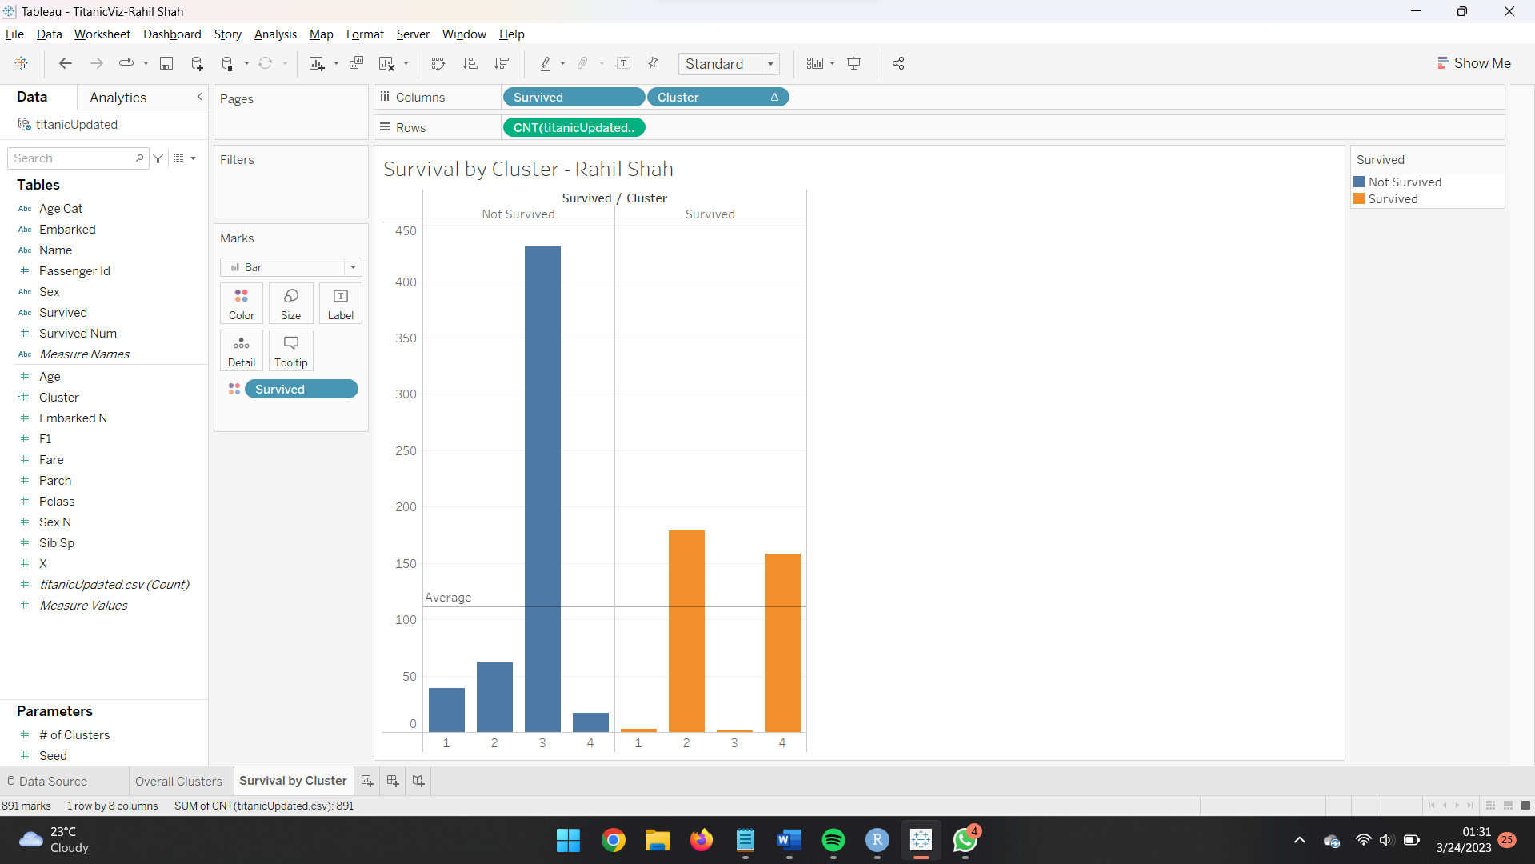

**Q 13)**

Two clusters where survivability is highest are cluster 2 and cluster 4.

**Q 14)**

|  |  |  |
| --- | --- | --- |
|  | <Cluster 2> | <Cluster 4> |
| Ideal Gender |  |  |
| Ideal Passenger Class |  |  |
| Ideal Age Category |  |  |
| Ideal Embarked point |  |  |
| Ideal number of siblings |  |  |

**Q15)**

**Q16)**

If you are a female then the high probability of survival is in Cluster 3

**Q17)**

|  |  |  |
| --- | --- | --- |
|  | <Cluster 2> | <Cluster 4> |
| Ideal Gender | Male | Female |
| Ideal Passenger Class |  |  |
| Ideal Age Category |  |  |
| Ideal Embarked point |  |  |
| Ideal number of siblings |  |  |

**Q18)**

**Q19)**

|  |  |  |
| --- | --- | --- |
|  | <Cluster 2> | <Cluster 4> |
| Ideal Gender | Male | Female |
| Ideal Passenger Class | 1 | 1 |
| Ideal Age Category |  |  |
| Ideal Embarked point |  |  |
| Ideal number of siblings |  |  |

**Q20)**

**Q21)**

|  |  |  |
| --- | --- | --- |
|  | <Cluster 2> | <Cluster 4> |
| Ideal Gender | Male | Female |
| Ideal Passenger Class | 1 | 1 |
| Ideal Age Category | 17 - 32 | 17 - 32 |
| Ideal Embarked point |  |  |
| Ideal number of siblings |  |  |

**Q22)**

**Q23)**

|  |  |  |
| --- | --- | --- |
|  | <Cluster 2> | <Cluster 4> |
| Ideal Gender | Male | Female |
| Ideal Passenger Class | 1 | 1 |
| Ideal Age Category | 17 – 32 | 17 – 32 |
| Ideal Embarked point | Southampton | Cherbourg |
| Ideal number of siblings |  |  |

**Q24)**

**Q25)**

|  |  |  |
| --- | --- | --- |
|  | <Cluster 1> | <Cluster 2> |
| Ideal Gender | Male | Female |
| Ideal Passenger Class | 1 | 1 |
| Ideal Age Category | 17 – 32 | 17 – 32 |
| Ideal Embarked point | Southampton | Cherbourg |
| Ideal number of siblings | 0 | 0 |

**Q26)**

1. The passenger from cluster 2 who is a male, has a passenger class of 1, is between age range of 17 and 32, embarked from Southampton, and has no siblings has the highest chance of surviving.
2. The passenger from cluster 4 who is female, has a passenger class of 1, is between age range of 17 and 32, embarked from Cherbourg, and has no siblings has the highest chance of surviving.